**S3 Bucket and Website Hosting,AWS Bucket Hosting and Versioning**

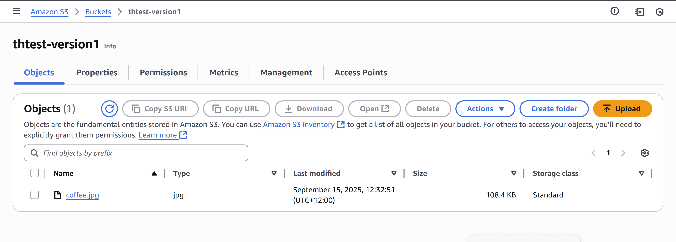

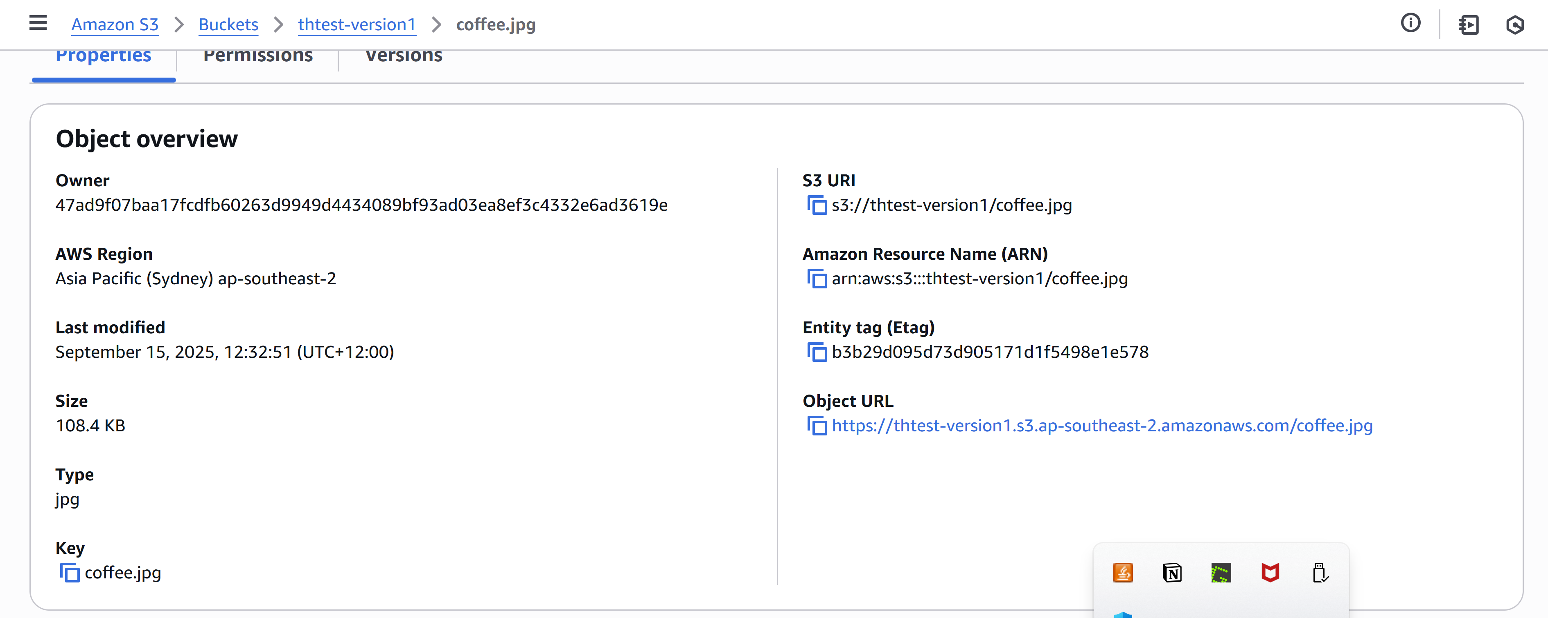



**Object cannot be seen as no Public URL**

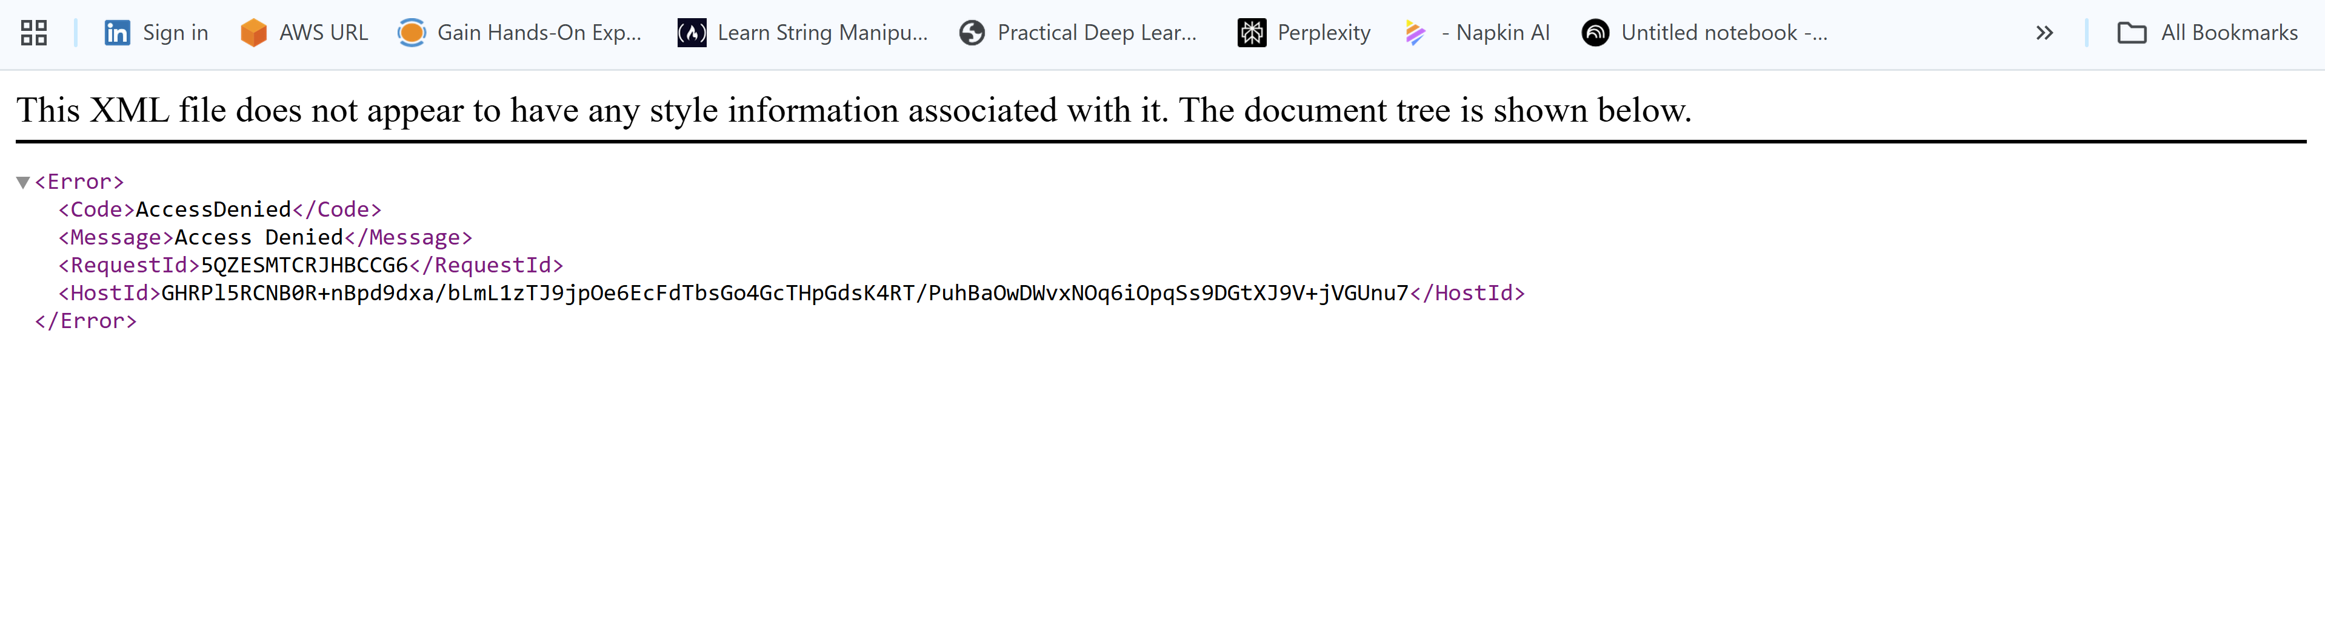

**Public URL is encoded and masked and not visible**

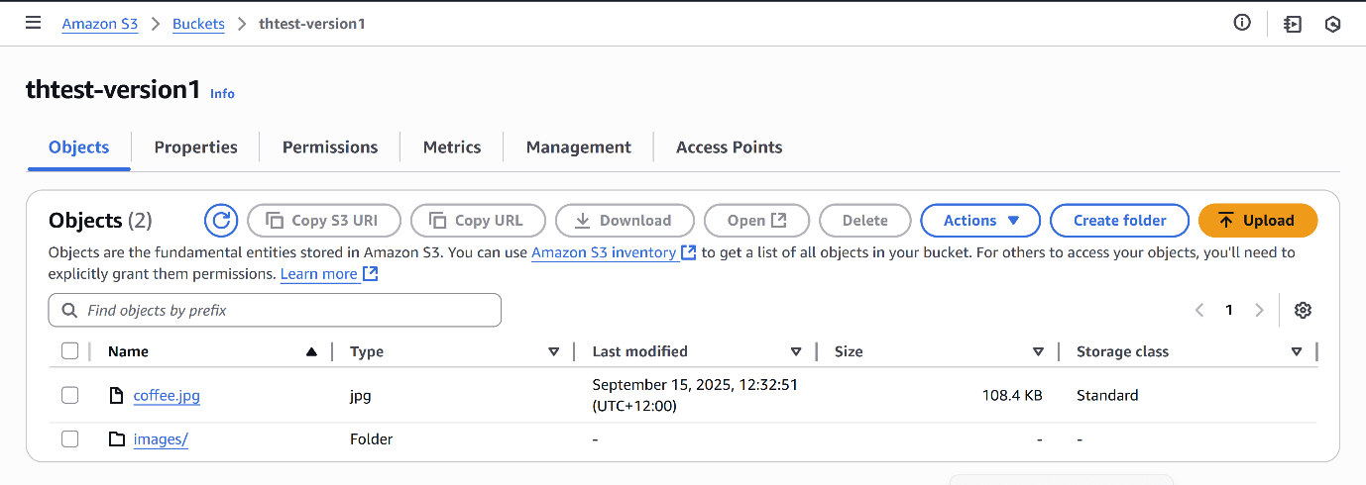

**Change of S3 Bucket Policy**

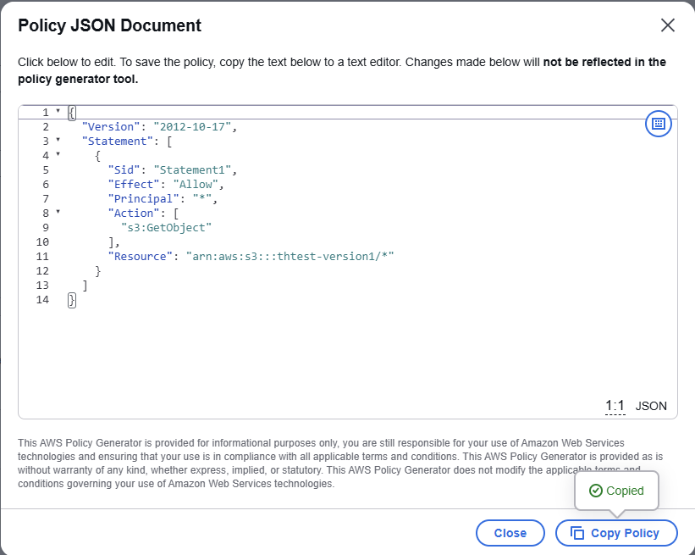



**Now the URL is working as**

**Static Website**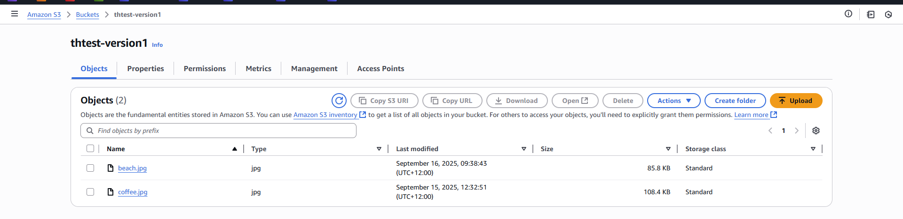

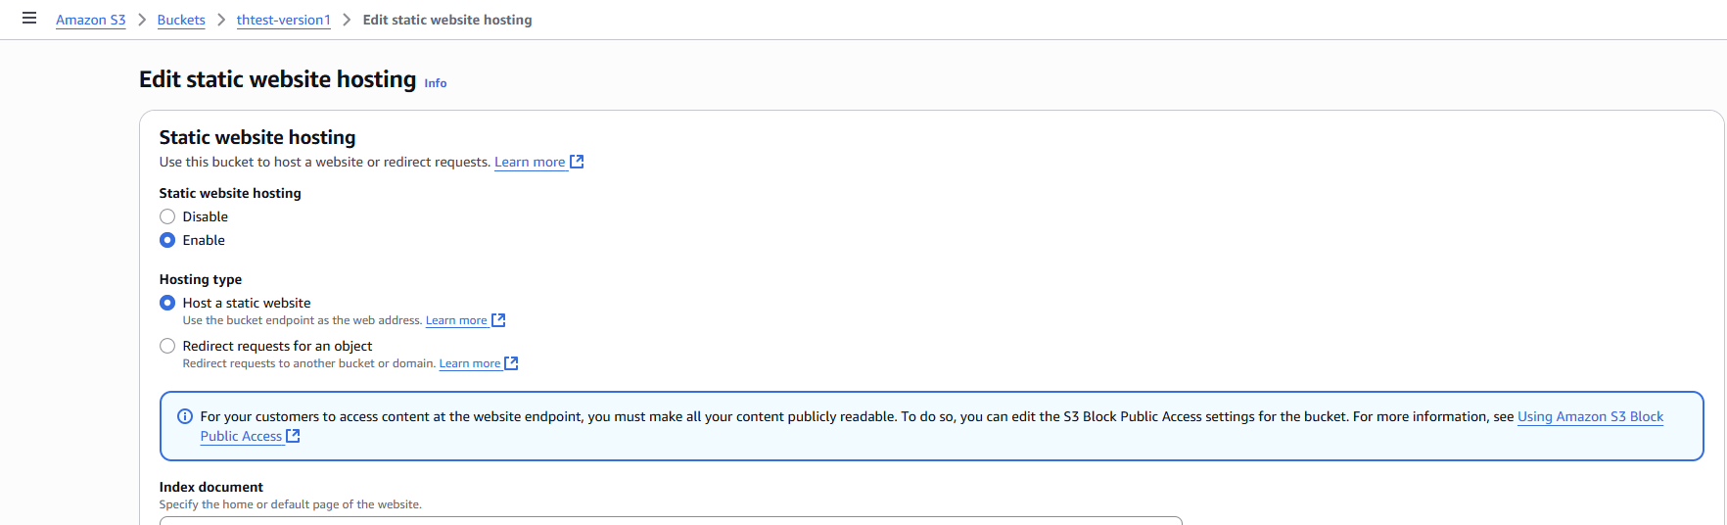

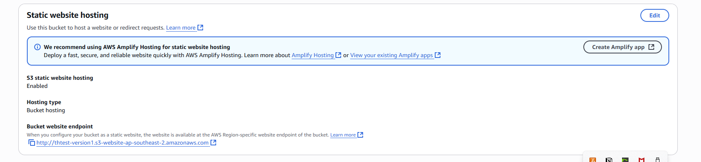

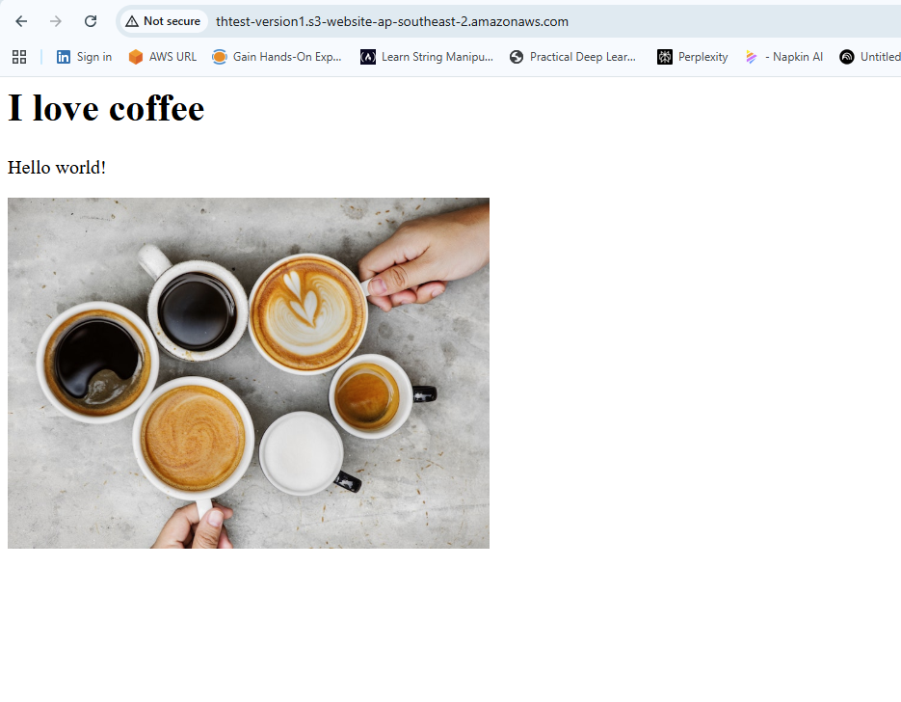

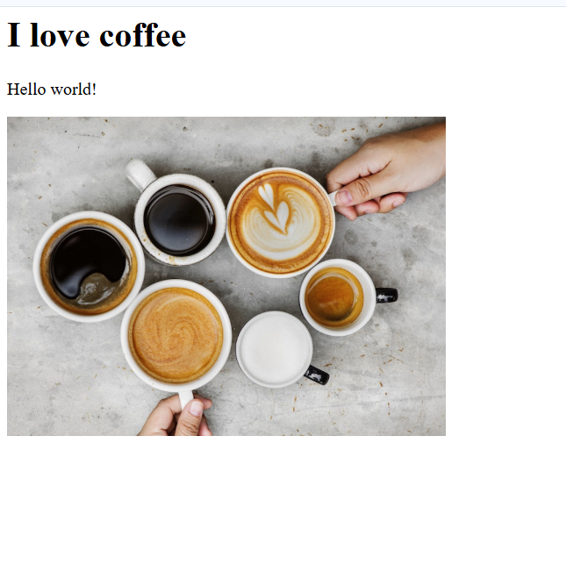

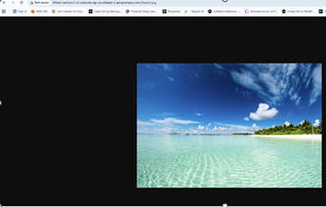

**Bucket Versioning**

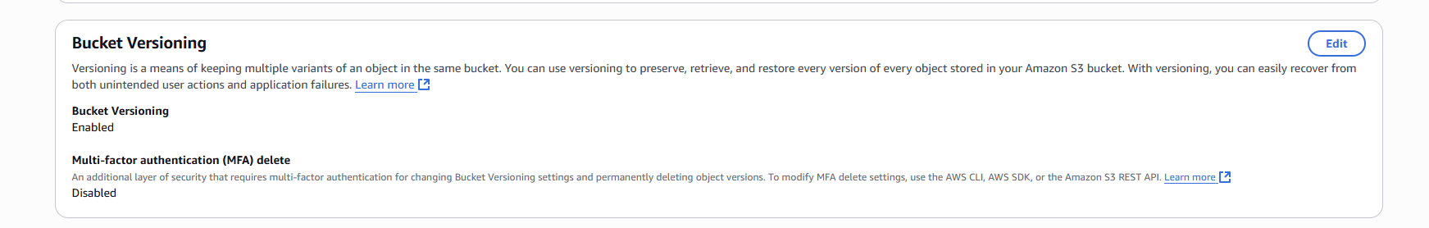

**Versioning**

